# Apply filters to SQL queries

## Project description

In this scenario, we needed to obtain specific information about employees, their machines, and the departments they belong to from the database. Your team needs data to investigate potential security issues and to update computers. You are responsible for filtering the required information from the database.

## Retrieve after hours failed login attempts

Following a breach due to improper updates on company computers, our security team was tasked with identifying events and gaps so that future solutions can be deployed. We began with broad strokes, starting with login attempts initiated outside of standard company hours. We were able to isolate the breach as originating on the 8th or 9th May 2022. This information was mainly pulled from the log_in_attempts table, utilizing keywords within the WHERE clause to filter the output appropriately.

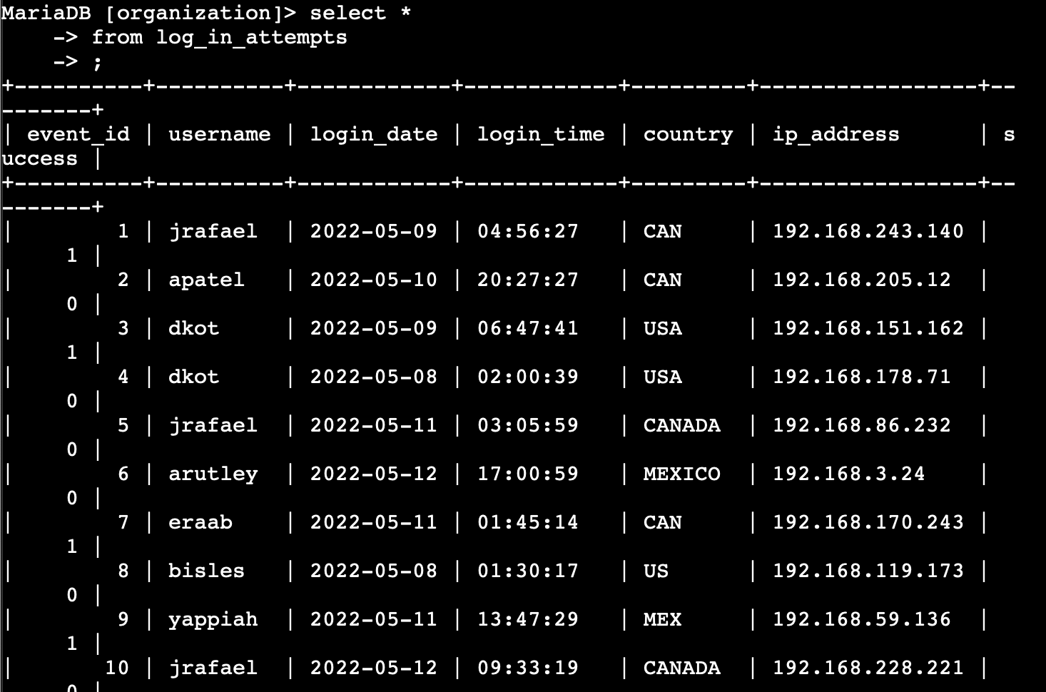

## 

## Retrieve login attempts on specific dates

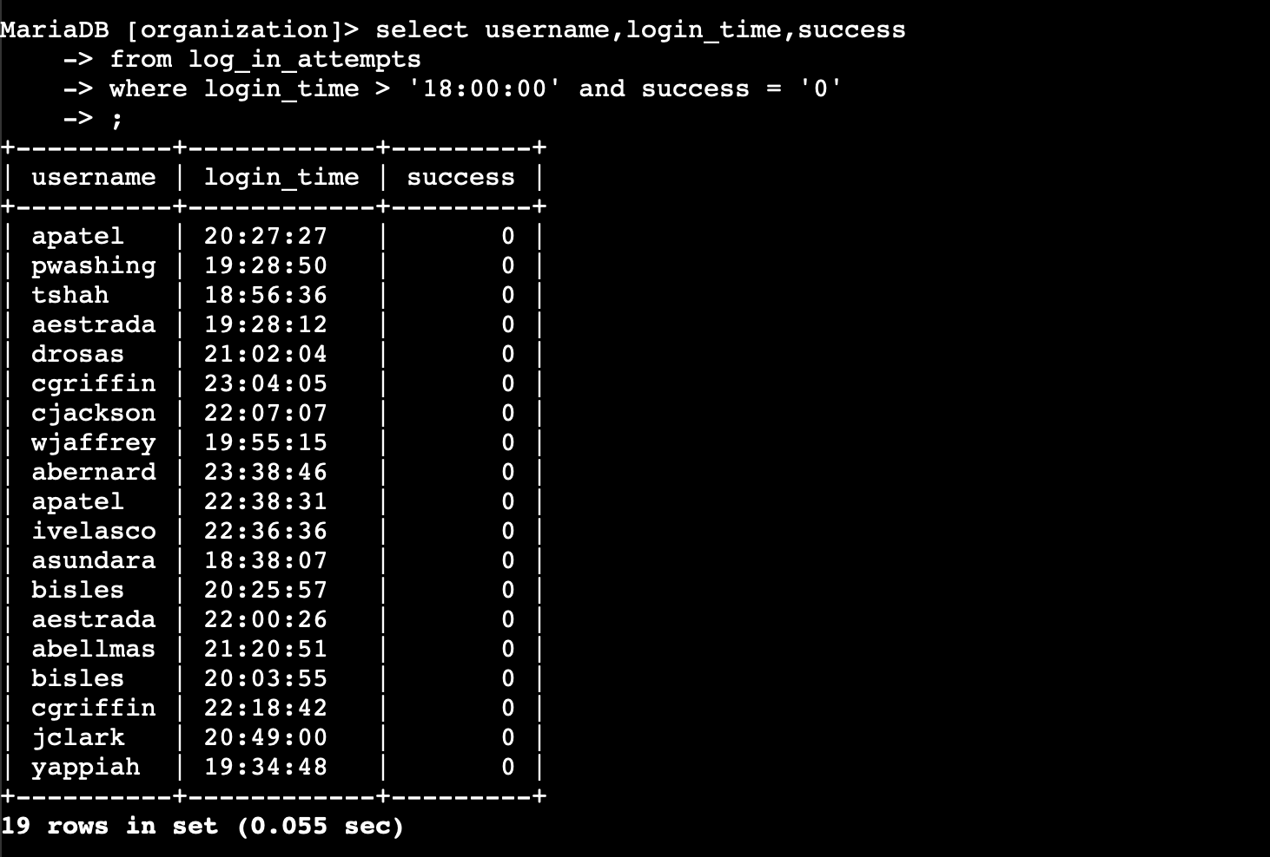

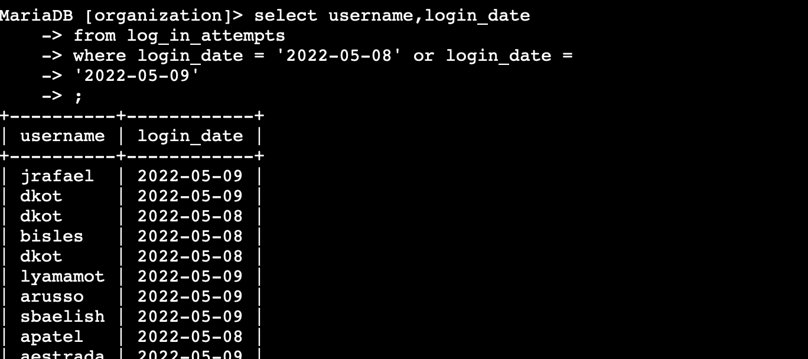

## Retrieve login attempts outside of Mexico

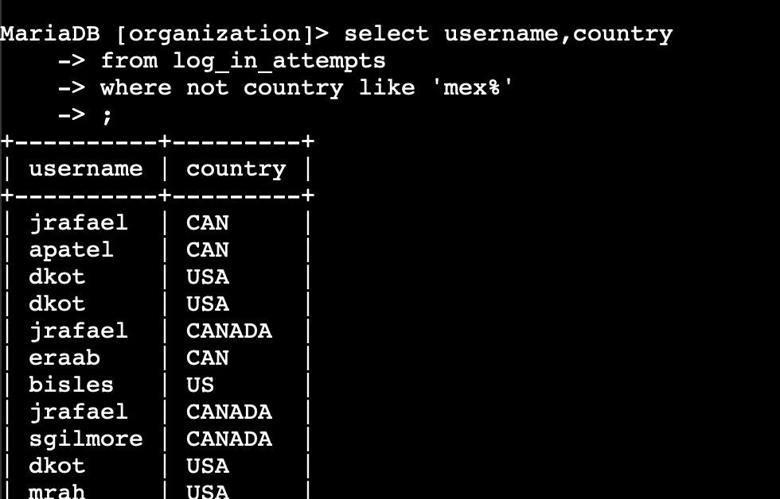

## Retrieve employees in Marketing

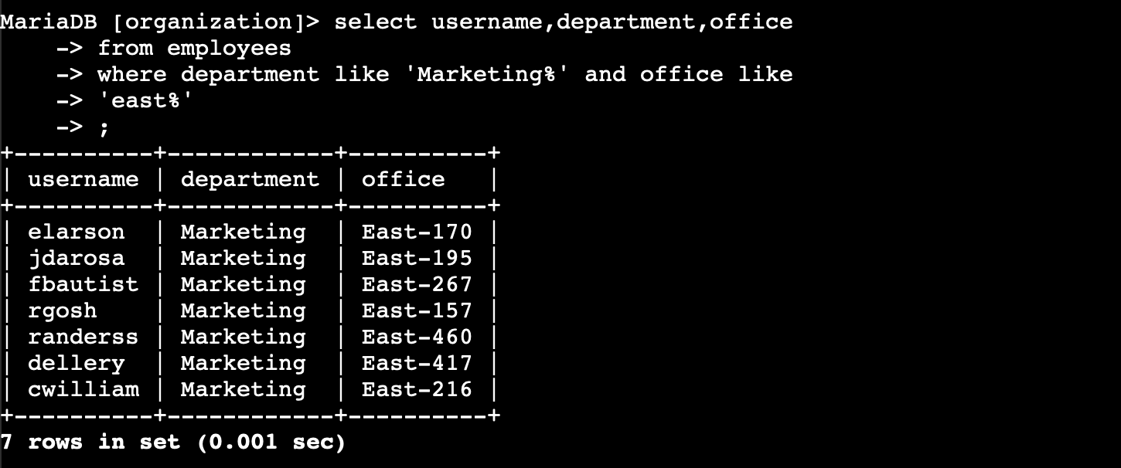

## Retrieve employees in Finance or Sales

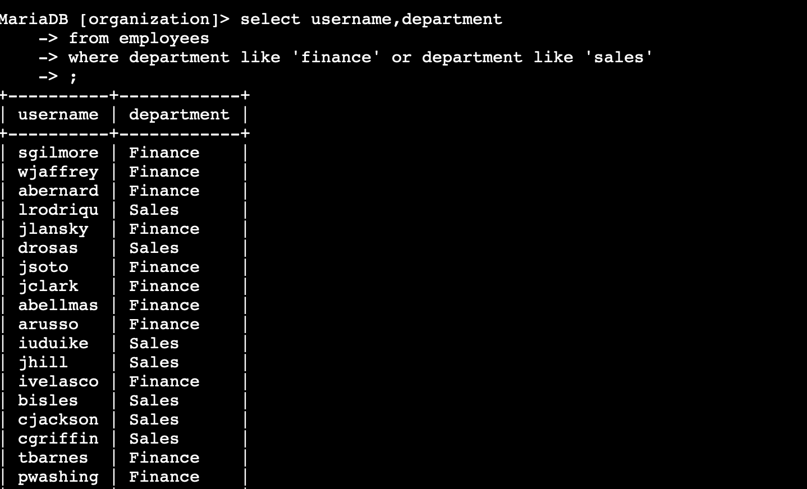

## Retrieve all employees not in IT

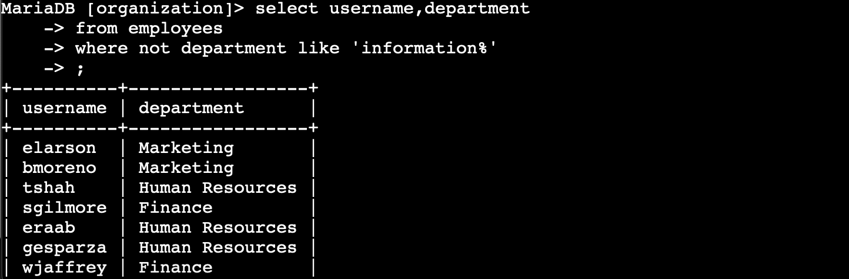

## Summary

[Add content here.]